Installing a Polycom E500 phone

1. Open the box, In the box you have the Phone, Phone Stand, Handset, Curly Handset Cable and one black internet cable.

2. Take the Phone stand and set it into the long slot on the back of the phone (Phone Stand will be inserted into the phone with the rubber feet pointing down)

3. Grab the curly cord and look for the end where there’s more space between the tip of the cord and the first loop.

4. Take that end of the cord and plug it into the phone. You'll find the port on the bottom right side. There’s a small picture of a handset below the port to guide you.

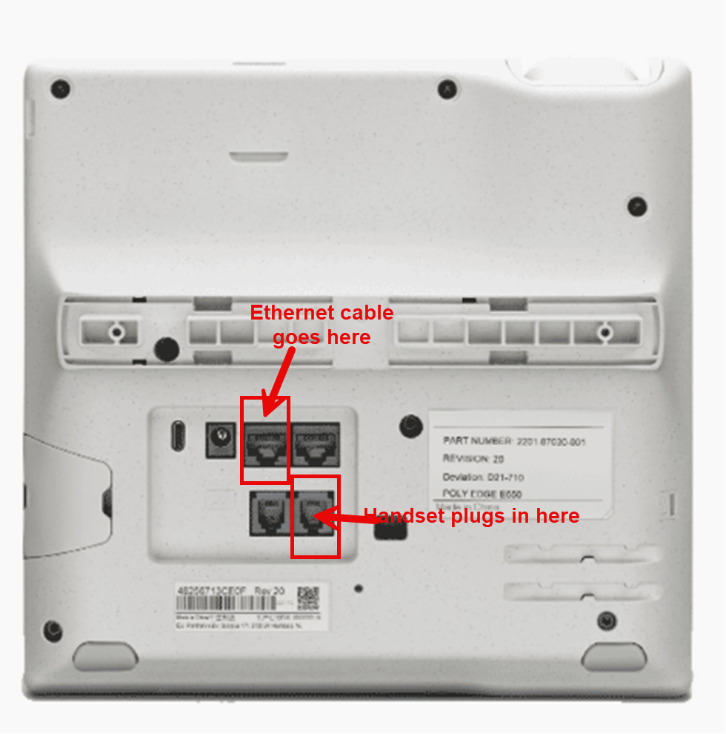

5. Now, look at the back of the phone again. You’ll see two ports at the top. The one on the far left has a picture of three boxes connected together, and the one on the right has a picture of a computer underneath it.

6. Take the seven-foot black internet cable and plug it into the port on the left, the one with the picture of the three boxes.

7. Take the other end of that internet cable and plug it into your network drop on your wall.

(If the phone has to plug into the pc, at this point you will take the 2nd internet cable and plug it into the port on the right with the picture of a laptop etched into the phone and take the other end and plug into the back of the pc in an available ethernet port).

8. Go ahead and flip your phone over. The Phone should be powering on and start registering to your network. (It will take a few mins to load all the way up)

Your Phone is ready for you.

**If the phone does not come up, open a ticket with IT** **Infrastructure Services**, as they may need to reconfigure the switch port to work for data and phone (voip), combined.  Advise them that you have a daisy-chained phone that is not working and needs a switch port configured properly.